**GROUP 807**

Name: Md. Alvee Ehsan ID: 20101123

Name: Yasmin Nadia ID: 19301241

Name: Dhruba Nandi ID: 19301256

Name: Abdullah Al Fahim ID: 19101567

**Topology Diagram:**

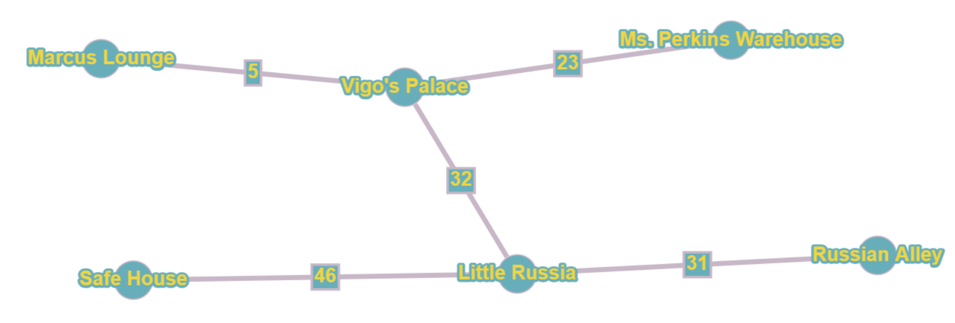

**VLSM Table:**

**NA = 192.168.0.0/17**

| **Host Name** | **Host Requirements** | **Actual Host** | **IP Block Size** | **Host Bits Required** | **Network Bits Required** |
| --- | --- | --- | --- | --- | --- |
| **Ms. Perkins** | 6546 | 6548 | 8192 | 13 | 19 |
| **Vigo's Palace** | 4565 | 4567 | 8192 | 13 | 19 |
| **Russian Alley** | 3000 | 3002 | 4096 | 12 | 20 |
| **Little Russia** | 1236 | 1238 | 2048 | 11 | 21 |
| **Marcus Loounge** | 756 | 758 | 1024 | 10 | 22 |
| **Safe House** | 200 | 202 | 256 | 8 | 24 |
| **w1** | 2 | 4 | 4 | 2 | 30 |
| **w2** | 2 | 4 | 4 | 2 | 30 |
| **w3** | 2 | 4 | 4 | 2 | 30 |
| **w4** | 2 | 4 | 4 | 2 | 30 |
| **w5** | 2 | 4 | 4 | 2 | 30 |
| **Floating route WAN** | 2 | 4 | 4  **Total = 23832** | 2 | 30 |

**IP Address Table:**

| **Marcus Lounge** | | | | |
| --- | --- | --- | --- | --- |
| **Device** | **Interface** | **IP address** | **Subnet Mask** | **Default Gateway** |
| PC4 |  | 192.168.88.4 | 255.255.252.0 | 192.168.88.1 |
| PC5 |  | 192.168.88.3 | 255.255.252.0 | 192.168.88.1 |
| DNS |  | 192.168.88.6 | 255.255.252.0 | 192.168.88.1 |
| DHCP |  | 192.168.88.2 | 255.255.252.0 | 192.168.88.1 |
| Marcus Lounge | Fa0/0  Se2/0  Se3/0 | 192.168.88.1  192.168.93.17  192.168.93.21 | 255.255.252.0  255.255.255.252  255.255.255.252 |  |
| Web Server |  | 192.168.88.5 | 255.255.252.0 | 192.168.88.1 |
| **Safe House** | | | | |
| **Device** | **Interface** | **IP address** | **Subnet Mask** | **Default Gateway** |
| user1@example2.com |  | 192.168.92.2 | 255.255.255.0 | 192.168.92.1 |
| user4@example2.com |  | 192.168.92.3 | 255.255.255.0 | 192.168.92.1 |
| Printer0 |  | 192.168.92.4 | 255.255.255.0 | 192.168.92.1 |
| Laptop0 |  | 192.168.92.5 | 255.255.255.0 | 192.168.92.1 |
| Safe House | Fa0/0  Se2/0 | 192.168.92.1  192.168.93.5 | 255.255.255.0  255.255.255.252 |  |
| **Little Russia** | | | | |
| **Device** | **Interface** | **IP address** | **Subnet Mask** | **Default Gateway** |
| PC1 |  | 192.168.80.4 | 255.255.248.0 | 192.168.80.1 |
| PC3 |  | 192.168.80.3 | 255.255.248.0 | 192.168.80.1 |
| DHCP1 |  | 192.168.80.2 | 255.255.248.0 | 192.168.80.1 |
| Little Russia | Fa0/0  Se2/0  Se3/0  Se6/0 | 192.168.80.1  192.168.93.2  192.168.93.6  192.168.93.10 | 255.255.248.0  255.255.255.252  255.255.255.252  255.255.255.252 |  |
| **Russian Alley** | | | | |
| **Device** | **Interface** | **IP address** | **Subnet Mask** | **Default Gateway** |
| PC0 |  | 192.168.64.4 | 250.250.240.0 | 192.168.64.1 |
| PC10 |  | 192.168.64.3 | 250.250.240.0 | 192.168.64.1 |
| DHCP2 |  | 192.168.64.2 | 250.250.240.0 | 192.168.64.1 |
| Russian Alley | Fa0/0  Se2/0  Se3/0 | 192.168.64.1  192.168.93.1  192.168.93.22 | 255.255.240.0  255.255.255.252  255.255.255.252 |  |
| **Ms. Perkins Warehouse** | | | | |
| **Device** | **Interface** | **IP address** | **Subnet Mask** | **Default Gateway** |
| user2@example2.com |  | 192.168.0.4 | 255.255.224.0 | 192.168.0.1 |
| user3@example2.com |  | 192.168.0.6 | 255.255.224.0 | 192.168.0.1 |
| DHCP6 |  | 192.168.0.2 | 255.255.224.0 | 192.168.0.1 |
| Email Server |  | 192.168.0.5 | 255.255.224.0 | 192.168.0.1 |
| Ms. Perkins | Fa0/0  Se2/0 | 192.168.0.1  192.168.93.13 | 255.255.224.0  255.255.255.252 |  |
| **Vigo’s Pal** | | | | |
| **Device** | **Interface** | **IP address** | **Subnet Mask** | **Default Gateway** |
| PC |  | 192.168.32.2 | 255.255.224.0 | 192.168.32.1 |
| PC2 |  | 192.168.32.3 | 255.255.224.0 | 192.168.32.1 |
| Vigo’s Pal | Fa0/0  Se2/0  Se3/0  Se6/0 | 192.168.32.1  192.168.93.18  192.168.93.14  192.168.93.9 | 255.255.224.0  255.255.255.252  255.255.255.252  255.255.255.252 |  |

**Project Assumptions:**

1. Both **Ms. Perkin's warehouse** and **Safe House** will use the same Domain Name for exchanging emails (**@example2.com**).
2. An extra WAN network is set between **Marcus Lounge** and **Russian Alley**. This floating route will be used only when **WAN 1** and **WAN 5 networks** can’t be reached.
3. “[www.marcuslounge.org](http://www.marcuslounge.org)” is the URL used for the **Marcus Lounge** Web Server.

**Routing Commands:**

**Russian Alley**

router rip

Version 2

network 192.168.64.0

network 192.168.93.0

ip route 192.168.88.0 255.255.252.0 Se3/0 5

**Little Russia**

router rip

version 2

network 192.168.80.0

network 192.168.93.0

**Safe house**

router rip

version 2

network 192.168.92.0

network 192.168.93.0

**Vigos’s Palace**

router rip

version 2

network 192.168.32.0

network 192.168.93.0

Ip route 192.168.0.0 255.255.224.0 192.168.93.13

Ip route 192.168.88.0 255.255.252.0 192.168.93.17

**Marcus Lounge**

Ip route 192.168.32.0 255.255.224.0 192.168.93.18

Ip route 192.168.0.0 255.255.224.0 192.168.93.18

Ip route 192.168.92.0 255.255.255.0 192.168.93.18

Ip route 192.168.80.0 255.255.248.0 192.168.93.18

Ip route 192.168.64.0 255.255.240.0 192.168.93.18

Ip route 192.168.64.0 255.255.240.0 Se3/0 5

**Ms. Perkins**

Ip route 192.168.32.0 255.255.224.0 192.168.93.18

Ip route 192.168.88.0 255.255.252.0 192.168.93.18

Ip route 192.168.92.0 255.255.255.0 192.168.93.18

Ip route 192.168.80.0 255.255.248.0 192.168.93.18

Ip route 192.168.64.0 255.255.240.0 192.168.93.18